FCC lists 99 Entities Ready to Bid in Spectrum Auction
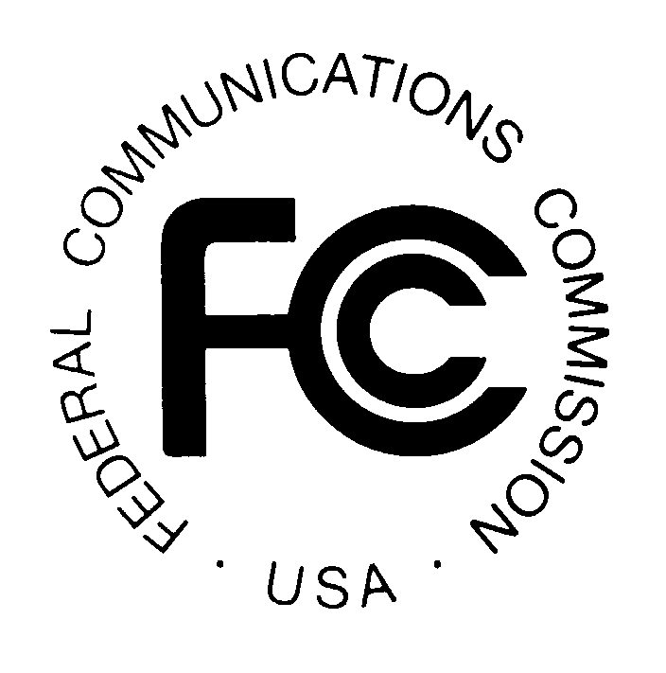
With the Federal Communications Commission prepping to begin the forward auction portion of the spectrum bidding process early next month, the agency has issued its list of 99 parties that have met the requirements to proceed. Five applicants were rejected for missing a filing deadline. Industry observers say the list contains few surprises.
Bloomberg BNA 5.12.16
http://www.bna.com/fcc-publishes-final-b57982072301/

