FCC Plans to Fine Sinclair $13.3 Million Over Undisclosed Commercials
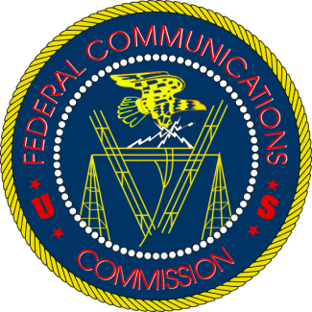
The proposed fine, which covers about 1,700 spots including commercials that looked like news stories that aired during newscasts for the Utah-based Huntsman Cancer Institute over a six-month period in 2016, could bolster critics of Sinclair’s proposed $3.9 billion acquisition of Tribune Media Co.
Reuters 12.15.17
https://www.reuters.com/article/us-sinclair-fcc-exclusive/exclusive-fcc-plans-to-fine-sinclair-13-3-million-over-undisclosed-commercials-idUSKBN1E92C7?utm_source=API+Need+to+Know+newsletter&utm_campaign=96df94e658-EMAIL_CAMPAIGN_2017_12_18&utm_medium=email&utm_term=0_e3bf78af04-96df94e658-31697553

