FCC Report Says Digital Divide is Smaller
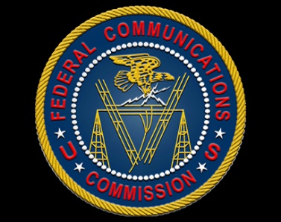
The Federal Communications Commission's 2019 Broadband Deployment report reveals that the gap in the country's digital access is 25% smaller than it was in 2016, thanks to timely broadband deployment. Democrats are expected to challenge those findings, with Commissioner Jessica Rosenworcel already tweeting that millions of homes still lack high-speed internet access.
Multichannel News 2/19/19
https://www2.smartbrief.com/redirect.action?link=https%3A%2F%2Fwww.multichannel.com%2Fnews%2Ffcc-digital-divide-has-substantially-narrowed&encoded=lkphDwljfkhGujqkaudavMaloWCc

