FCC Reports Some Stations Still Dark Following Delta
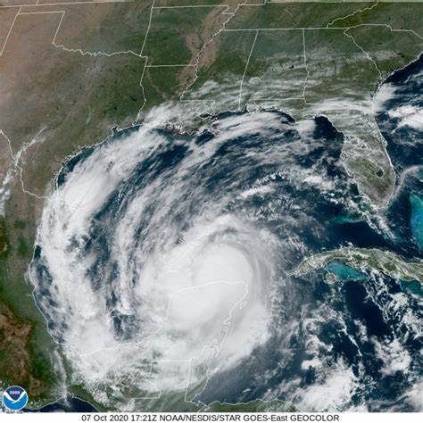
Hurricane Delta took out 17 or more Louisiana radio stations when it made landfall, and the Federal Communications Commission says that at least seven remained offline as of Oct. 12, with others possibly choosing not to or unable to report outages. The agency still wants daily updates from outlets in 21 of the state's counties.
Inside Radio (free content) 10/12/20
http://www.insideradio.com/free/seven-gulf-coast-radio-stations-still-silenced-by-hurricane-delta-fcc-says/article_0154fdd6-0ccd-11eb-871d-2fab63363244.html
Image credit:
https://cdnph.upi.com/svc/sv/i/4761601899519/2020/1/16020918797980/Hurricane-Delta-to-strengthen-as-it-blitzes-across-Gulf-of-Mexico.jpg

