NAB Welcomes FCC Rule Approving All-Digital AM
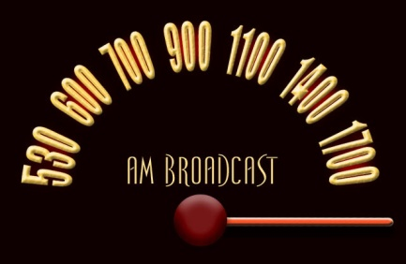
The Federal Communications Commission says it will permit AM radio outlets to voluntarily broadcast entirely digital programming, provided each offers a minimum of one over-the-air stream that matches or exceeds analog quality. Gordon Smith, CEO of the National Association of Broadcasters, welcomed the move, noting that it "provides AM stations with essential flexibility to provide interference-free broadcasts and attract new listeners."
All Access Music Group 10.27.20
https://www.allaccess.com/net-news/archive/story/201344/fcc-approves-rule-change-allowing-am-stations-to-g
Image credit:
https://thedailyparks.files.wordpress.com/2016/03/am-old-time-dial.jpg

