FCC Seeks Comment on "Video-Related Fees" in Cable Bills
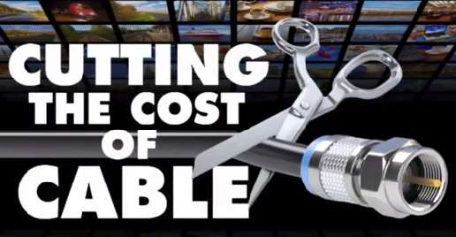
The Federal Communications Commission Media Bureau is seeking comment on the addition of "video-related fees" to subscriber bills in lieu of "raising monthly subscription prices." The comment period will last until Sept. 21.
Multichannel News 7/20/15
http://www.multichannel.com/fcc-eyeing-cable-bill-breakouts/392295

