FCC Sets March Vote on Anti-Robocall Mandate
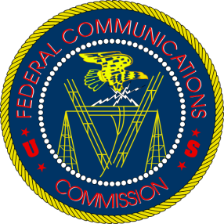
All telephone service providers, including cable companies, would have to deploy STIR/SHAKEN technology to help prevent illegal robocalls under rules that will get a Federal Communications Commission vote at the end of this month. The four largest carriers have already implemented the protocol but the proposed FCC rule would require others to do so by July 20 next year, with a potential one-year extension for rural and small providers.
Ars Technica 3.6.20
https://arstechnica.com/tech-policy/2020/03/ajit-pai-follows-congress-instructions-requires-new-anti-robocall-tech/

