FCC Spectrum Auction: Winners and Losers
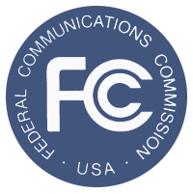
The FCC is buying back the spectrum to resell it to the big wireless providers like AT&T to enable the building out of the nation’s digital capabilities. Among the winners, TV station owners who take the deal. Essentially the FCC will be paying them potentially hundreds of millions to go off the air, way over their market value.
MediaLife 12.14.15
http://www.medialifemagazine.com/fcc-spectrum-auction-winners-losers/

