FCC Spectrum Auction to End at Stage 4 with $18.2B
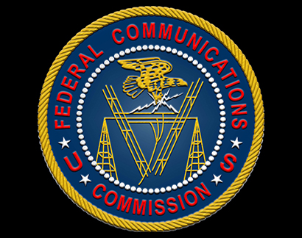
The Federal Communications Commission's spectrum auction ended with bids totaling $18.2 billion, satisfying the auction's Final Stage Rule. Participating broadcast licensees will receive $10.05 billion, with the remaining funds being used to reduce the government's budget deficit.
TVNewsCheck 1/18/17
http://www.tvnewscheck.com/article/100815/incentive-auction-ending-at-18-billion

