FCC Targets Radio Pirates
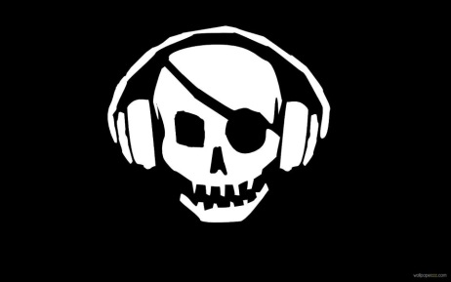
Federal Communications Commission Commissioner Michael O'Rielly says the commission is stepping up its efforts to crack down on pirate radio operators, who he says "are spreading like poison ivy in the garden of the radio spectrum." O'Rielly and his office are leading an initiative to educate advertisers, concert promoters, venue operators and others in the industry who may be unknowingly working with pirate operators.
RBR.com 2/9/16
http://rbr.com/orielly-pirates-spreading-like-poison-ivy/

