FCC To Hold License Renewal Hearing Regarding 2007 Contest
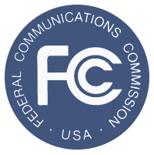
This one dates back nearly a decade and involves a contest KDND Sacramento held that lead to the death of one of its listeners. The hearing, regarding the license renewal of KDND Sacramento, stems from the 2007 contest called “Hold Your Wee for a Wii”.
RadioInk 10.28.16
http://radioink.com/2016/10/28/fcc-hold-license-renewal-hearing-regarding-entercoms-2007-contest/?utm_source=ActiveCampaign&utm_medium=email&utm_content=FCC+To+Hold+License+Renewal+Hearing+Regarding+Entercom+s+2007+Contest&utm_campaign=10+27+Thursday+Pandora+%28Copy%29

