FCC Turns Sights to Local Station Ownership
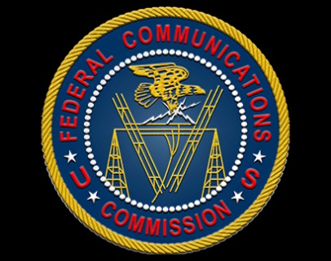
After loosening national ownership regulations, expectations are high that the FCC will move to allow two stations in every market regardless of whether or not they are network affiliates. Under one scenario, action could come as early as this summer.
TVNewsCheck 6.7.17
http://www.tvnewscheck.com/article/104733/fcc-turns-sights-to-local-station-ownership?utm_source=Listrak&utm_medium=Email&utm_term=FCC+Turns+Sights+To+Local+Station+Ownership&utm_campaign=FCC+Turns+Sights+To+Local+Station+Ownership

