FCC Unveils New Broadband Map
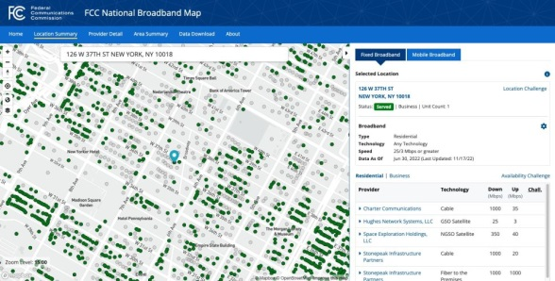
As promised, the FCC has released its first draft of a new broadband availability map meant to more accurately represent broadband coverage as the Biden administration pushes tens of billions of dollars toward its universal broadband pledge.
Next TV/Multichannel News 11/18/22
https://www.nexttv.com/news/fcc-unveils-new-broadband-map?utm_term=A25693A1-51B6-4112-BDE4-56BD420E983F&utm_campaign=C74FC4FA-5D4D-4151-8915-3043BA411DBE&utm_medium=email&utm_content=FC7B607C-E29F-4465-B780-6BC2A8C7B663&utm_source=SmartBrief
Image credit:
https://cdn.mos.cms.futurecdn.net/n6bZntmbgQjT6X3A4j4vGB-970-80.jpg

