FCC Votes to Move Public Files Online
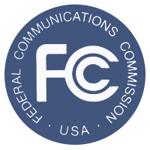
The Report and Order adopted Thursday calls for public files to be moved online immediately by stations in the top 50 markets with five or more employees. All other stations will have two years before they are required to move their public file online. The deadline to move online for stations outside the top 50 is March 1, 2018.
Radio Ink 1.28.16
http://radioink.com/2016/01/28/fcc-votes-to-move-public-files-online/?utm_source=ActiveCampaign&utm_medium=email&utm_content=It+s+Time+To+Ditch+The+Paper+Public+File&utm_campaign=Radio+Ink+-+Headlines+-+2016-01-29

