Federal Report Highlights Growing Video Piracy Threat
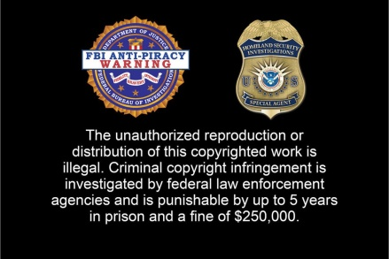
Content providers and creators face a growing threat from the illegal sale and streaming of video content, the federal administration says in its yearly Intellectual Property Report. The Motion Picture Association and the National Intellectual Property Rights Coordination Center, which is supervised by the Department of Homeland Security, have signed a Memorandum of Understanding on the issue.
TV Technology 1.5.21
https://www.tvtechnology.com/news/streaming-piracy-direct-threat-to-content-owners-providers-says-white-house?utm_source=SmartBrief&utm_medium=email&utm_campaign=3E572E13-3FBC-11D5-AD13-000244141872&utm_content=8F054978-1A4B-4953-AA9E-DFDC310964C1
Image credit:
https://cdn.vox-cdn.com/thumbor/PQLGojm_hh5QJ0Em6VRibbvXCxU=/0x58:1100x791/1200x800/filters:focal(0x58:1100x791)/cdn.vox-cdn.com/assets/1108977/apw-1_original.jpeg

