Feds Probe China's Role in Radio Station Operations
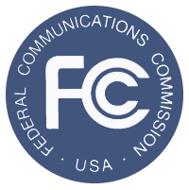
A California-based company that's under majority control by a unit of China's state-run radio broadcaster is being investigated by federal officials for its operations under leases or other agreements of radio stations in Washington, D.C., Philadelphia and San Francisco, among more than a dozen other cities. Federal law allows foreign individuals, governments and businesses to retain as much as 20% direct ownership of a station or 25% of its parent company, but bans them from being the holder of a station's license.
Reuters 11/2/15
http://www.reuters.com/article/2015/11/02/us-china-radio-fcc-idUSKCN0SR2AI20151102

