Female Journalists Seek Support Amid Online Attacks
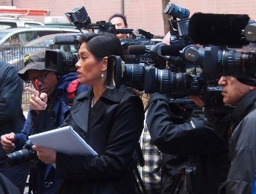
A growing number of women in journalism are asking the organizations they work for to support them against rising misogyny online, warning that the traditional approach of ignoring abuse is not viable. Some point out that the majority of media outlets have male leaders, who haven't experienced and don't understand the toxicity female reporters endure and the effects attacks can have on their careers.
Vanity Fair online 3.26.21
https://www.vanityfair.com/news/2021/03/harassment-of-female-journalists-is-putting-news-outlets-to-the-test
Image credit:
https://journalismresearchnews.org/wp-content/uploads/2016/09/press1.jpg

