Fewer Complaints Logged For Super Bowl Halftime Show
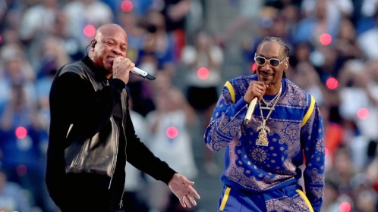
The Federal Communications Commission received just 33 complaints about this year's Super Bowl halftime show, The Hill reports. By comparison, the FCC logged 1,300 complaints about the 2020 show and 50 about the 2019 event.
The Hill 3/1/22
https://thehill.com/blogs/in-the-know/in-the-know/596311-super-bowl-halftime-show-draws-33-fcc-complaints-compared-to
Image credit:
https://nationworldnews.com/wp-content/uploads/2022/02/Dr-Dre-Snoop-Dogg-Lead-Super-Bowl-Halftime-Show-Packed-1068x600.jpeg

