Fewer Product Placements on Broadcast Nets
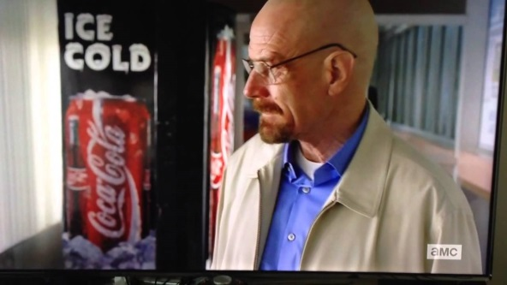
TV primetime branded product placements continue to slowly decline on broadcast networks. In the 2016-17 TV season, there were 4% fewer in-program placements — on-screen brands or products airing within a program — 4,346 versus the 2015-16 TV season, when there were 4,538 placements.
MediaPost 10.5.17
https://www.mediapost.com/publications/article/308281/fewer-branded-product-placements-appear-on-broadca.html
Image source:
http://www.flanderstoday.eu/sites/default/files/webimages/product_placement.jpg

