FICCI FLO Film Festival to Feature Women-Centric Films, Documentaries
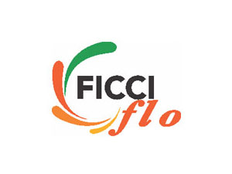
Women-centric films from all over the world will feature prominently at this week's FICCI FLO film festival in Mumbai, including Deniz Gamze Erguven's "Mustang" and Shonali Bose's "Margarita with a Straw." Documentaries ranging from Rebecca Barry's "I Am A Girl," which examines the lives of teenage girls from six different countries.
The Hindu (India) 2/16/16
http://www.thehindu.com/news/cities/mumbai/entertainment/the-many-roles-of-women/article8243462.ece

