NAB: Automakers Know How To Include AM In EVs
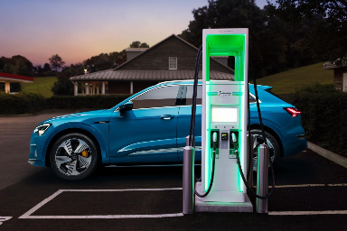
The National Association of Broadcasters is pushing back against claims that the 2.2 pounds of weight AM radio adds to electric vehicles is a problem, noting the average EV battery weighs more than 1,000 pounds. "Many automakers have already figured out a way to include AM radio in their electric models," the NAB says, noting that 12 of the 20 automakers mentioned in a Center for Automotive Research report issued last week include or plan to include AM in their EV dashboards.
Radio Ink 11.13.23
https://radioink.com/2023/11/13/nab-fights-back-as-automakers-try-to-wriggle-away-from-am/
Image credit:
https://audiclubna.org/etron/wp-content/uploads/sites/38/2018/10/Audi-e-tron-1600x1066.jpg

