First-Run Syndie Revival Continues In 2020
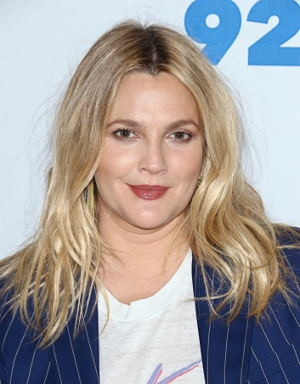
New first-run syndication programming experienced a bit of a revival in the fall of 2019 and that success seems like it could be duplicated in the fall of 2020. More than a half dozen first-run shows that premiered last September will return this fall and a handful of new shows with popular talent are expected to get broad national TV station clearance for this September.
TVNewsCheck 1.8.20
https://tvnewscheck.com/article/top-news/243061/first-run-syndie-revival-continues-in-2020/?utm_source=Listrak&utm_medium=Email&utm_term=First-Run+Syndie+Revival+Continues+In+2020&utm_campaign=First-Run+Syndie+Revival+Continues+In+2020
Image credit:
https://scstylecaster.files.wordpress.com/2018/03/drew-barrymore-blonde.jpg?w=799&h=1024

