First Women's Equality Film Series to Screen 15 Inspiring Female-Led Films
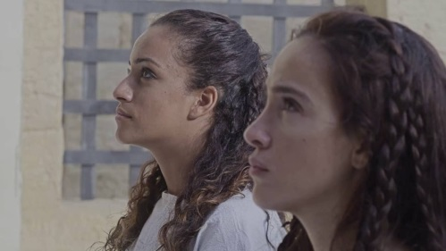
Harkins Theatres and STX Entertainment have partnered to host the first annual Women's Equality Film Series, highlighting the accomplishments of history-making women. The series will run from Sept. 28 to Oct. 4, with a portion of the proceeds going to support the work of the Geena Davis Institute on Gender in Media. "A League of Their Own," "Frida," "Hidden Figures," "Battle of the Sexes" and "Molly's Game" are among the 15 films being screened.
Film Journal International 9/14/18
http://www.filmjournal.com/news/harkins-announces-first-annual-womens-equality-film-series
Image credit:
https://i.ytimg.com/vi/CBzzW_b_qGc/maxresdefault.jpg

