Five Charts: The State of Ad Fraud
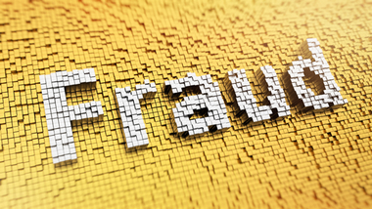
After analyzing 27 billion ad impressions across 50 brand marketers, White Ops and the ANA projected that $5.8 billion will be lost to fraud globally this year, down from $6.5 billion in 2017. In a poll of 317 US marketers by research firm Advertiser Perceptions, 37% of respondents said that fraud was one of the worst aspects of programmatic ad buying.
eMarketer 5.20.19
https://www.emarketer.com/content/five-charts-the-state-of-ad-fraud?ecid=NL1001
Image credit:
http://www.bizreport.com/images/shutterstock/2015/10/fraud_214632544-thumb-380xauto-4031.jpg

