Flagship Stations Earn Big Ratings with Postseason Games
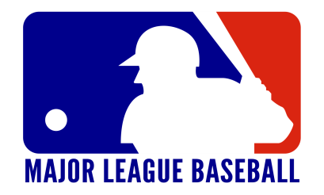
Radio broadcasts of this year's MLB playoffs gave flagship stations impressive 6+ shares. The season's big winners included WTMJ, home of the Milwaukee Brewers, which peaked with a 55.2 share during the National League Championship Series, and the Boston Red Sox's WEEI, which approached a 30 share during the World Series, which the team dominated.
Inside Radio (free content) 11/30/18
http://www.insideradio.com/baseball-postseason-delivers-big-hits-for-flagship-radio-stations/article_4bcdb5ca-f473-11e8-a93d-9f8b93a2706e.html

