For the ‘New Yellow Journalists,’ Opportunity Comes in Clicks and Bucks
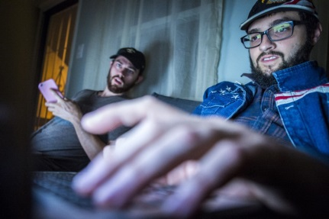
Fewer than 2,000 readers are on his website when Paris Wade, 26, awakens from a nap, reaches for his laptop and thinks he needs to, as he puts it, “feed” his audience. “Man, no one is covering this TPP thing.” He begins typing a story. “CAN’T TRUST OBAMA,” he writes as the headline. Ten minutes and nearly 200 words later, he is done with a story that is all opinion, innuendo and rumor.
Washington Post 11.20.16
https://www.washingtonpost.com/national/for-the-new-yellow-journalists-opportunity-comes-in-clicks-and-bucks/2016/11/20/d58d036c-adbf-11e6-8b45-f8e493f06fcd_story.html?wpisrc=nl_p1most-partner-1&wpmm=1

