For Univision, a New Way to Measure Ratings
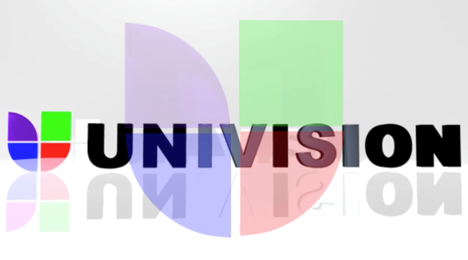
It’s become the first Spanish-language network to sign up for Nielsen’s new National and Local TV Digital Measurement. The service allows Univision and UniMás to include Nielsen digital audience measurements with their TV ratings. It will capture all viewing across TV, connected TV, DVRs, video on demand, mobile, tablets and desktop.
MediaLife 5.3.16
http://www.medialifemagazine.com/for-univision-a-new-way-to-measure-ratings/

