Forecast: Consumers Will Up Streaming Spending by 29%
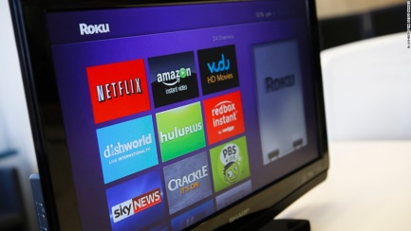
Consumers will spend about $24 billion on subscription-video services this year, a 29% rise from 2019, the Consumer Technology Association predicts pointing to the impending debut of several streaming providers and last year's launch of Disney Plus and Apple TV Plus. The study also forecasts 4K Ultra TV sets accounting for 25 million of the 40.8 million units shipped in the US.
Variety online 1/5/19
https://variety.com/2020/digital/news/streaming-video-consumer-spending-2020-forecast-1203455291/
image credit:
http://cdn.cnn.com/cnnnext/dam/assets/140424153843-web-streaming-tv-horizontal-large-gallery.jpg

