Fortnite's Getting Sued By Dance Choreographer
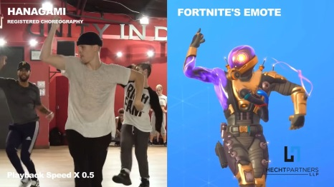
Lawyers representing choreographer Kyle Hanagami sued Epic Games for copyright infringement over the “It’s Complicated” dance emote in Fortnite. The in-game emote begins with movements which Hanagami’s lawyers allege are lifted from copyrighted dance moves created by the choreographer.
Kotaku 3.30.22
https://kotaku.com/fortnite-epic-games-lawsuit-dance-emote-kyle-hanagami-1848727617
Image credit:
https://i0.wp.com/justarticlessite.com/wp-content/uploads/2022/03/Fortnite-Sued-Over-Dance-Emote-By-Choreographer-To-Bieber-JLo.jpg?w=1200&ssl=1

