Four Major Studios Join U.S. Launch of Disney’s Movies Anywhere Digital Service
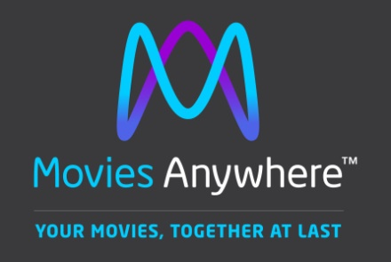
Using a free app and website, consumers can eligible movies by connecting their Movies Anywhere accounts with accounts at Amazon Video, Google Play, iTunes and Vudu. With their libraries synchronized across accounts, viewers can watch downloaded movies on Amazon Fire devices, Android devices and TVs, Apple TV, Chromecast, Roku and Apple iOS devices.
Deadline Hollywood 10.11.17
http://deadline.com/2017/10/four-major-studios-join-disney-movies-anywhere-digital-service-1202186760/

