‘Friends,’ ‘Grey’s Anatomy’ Were Most Binge-Watched TV Shows of 20188
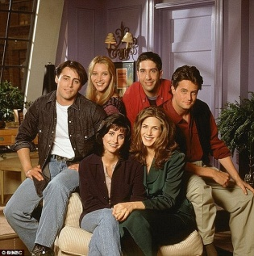
The sitcom about twentysomething New Yorkers nabbed the highest share of binge sessions over the course of the year, according to TV Time, based on its analysis of the behavior of 12 million registered users worldwide of its app for tracking, commenting on and voting for television shows.
Variety 12.20.18
https://variety.com/2018/tv/news/friends-greys-anatomy-most-binge-watched-2018-1203094184/
Image credit:
https://i.dailymail.co.uk/i/pix/2015/07/31/02/2AFAB24E00000578-3180780-Humble_beginnings_When_Friends_began_in_1994_the_cast_only_made_-a-5_1438307663594.jpg

