FTC Charges Volkswagen with Deceptive Advertising
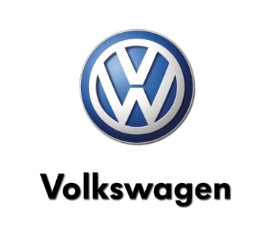
The FTC alleges in a complaint filed in federal court that Volkswagen during a seven-year period "deceived consumers by selling or leasing more than 550,000 diesel cars based on false claims that the cars were low-emission, environmentally friendly, met emissions standards and would maintain a high resale value,"
Advertising Age 3.29.16
http://adage.com/article/cmo-strategy/ftc-charges-volkswagen-deceptive-advertising/303306/?utm_source=breaking_news_alerts&utm_medium=newsletter&utm_campaign=adage&ttl=1459870183

