FTC Considers Endorsement Crackdown
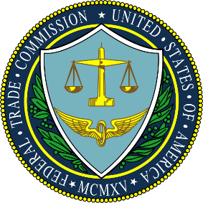
Endorsement ads across platforms have come under FTC scrutiny, and the agency could begin issuing fines for fake reviews. The proposal, which the FTC approved 3-1, states that "a civil penalty remedy may provide a potent deterrent" to fraudulent endorsements.
Inside Radio (free content) 10/24/22
https://www.insideradio.com/free/ftc-crackdown-on-endorsements-continues-with-new-proposal-to-create-fines/article_0a8d5330-5370-11ed-b983-478cc71e3b0d.html

