FTC Demands Accountability From Social Media
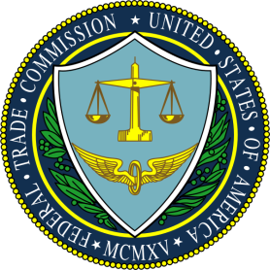
The Federal Trade Commission has given nine top social media and internet firms 45 days to provide details about "[how they] collect, use, and present personal information, their advertising and user engagement practices, and how their practices affect children and teens." No penalties apply if companies fail to answer, but Discord and Twitter both noted that they're working on responses.
The Verge 12.14.20
https://www.theverge.com/2020/12/14/22174755/ftc-data-privacy-youtube-facebook-reddit-twitter-snapchat-discord-inquiry

