FTC to Crack Down on Paid Celebrity Posts That Aren’t Clear Ads
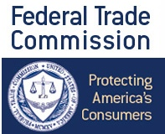
Snapchat star DJ Khaled raves about Ciroc vodka. The uptick in celebrities peddling brand messages on their personal accounts, light on explicit disclosure, has not gone unnoticed by the U.S. government. The Federal Trade Commission is planning to get tougher: Users need to be clear when they're getting paid to promote something, and hashtags like #ad, #sp, #sponsored --common forms of identification-- are not always enough.
Bloomberg Technology 8.5.16
http://www.bloomberg.com/news/articles/2016-08-05/ftc-to-crack-down-on-paid-celebrity-posts-that-aren-t-clear-ads?utm_source=API+Need+to+Know+newsletter&utm_campaign=217aa34e23-Need_to_Know_August_8_20168_8_2016&utm_medium=email&utm_term=0_e3bf78af04-217aa34e23-31697553

