FTC Warns Brands Using AI To Proceed With Caution
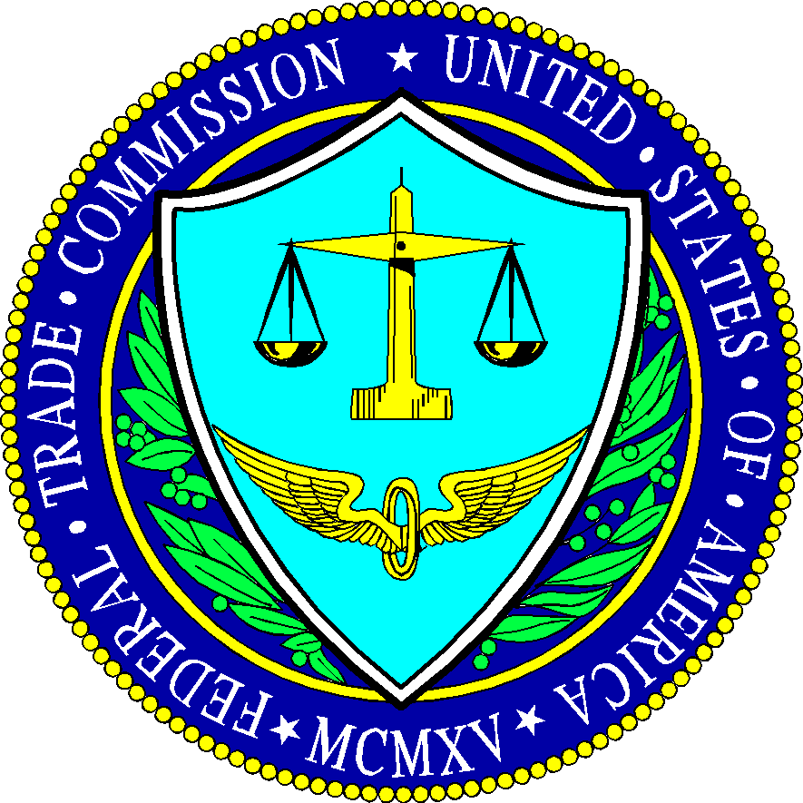
The Federal Trade Commission is monitoring the use of artificial intelligence for potential rule violations and would likely take action if the technology "unfairly or deceptively" directs an individual toward financial, health, education, housing or employment decisions that are harmful, said Michael Atleson, an attorney with the FTC Division of Advertising Practices, in a blog post. Atleson says brands "should always be clear that an ad is an ad."
Engadget 5.2.23
https://www.engadget.com/ftc-warns-tech-companies-against-ai-shenanigans-that-harm-consumers-175851417.html

