Gawker Media Files for bankruptcy
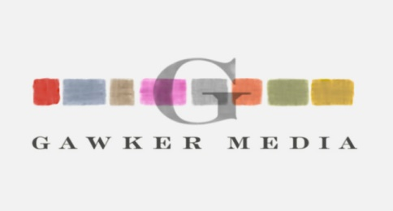
Gawker Media filed for Chapter 11 bankruptcy protection on Friday, in order to protect its assets from seizure by former professional wrestler Hulk Hogan. Simultaneously, Gawker Media parent company Gawker Media Group announced that it had agreed to sell its assets in an auction supervised by a bankruptcy court.
Politico Media 6.10.16
http://www.politico.com/media/story/2016/06/gawker-files-for-bankruptcy-to-protect-assets-from-hogan-004593?utm_source=API+Need+to+Know+newsletter&utm_campaign=89c5d69365-Need_to_Know_June_13_20166_13_2016&utm_medium=email&utm_term=0_e3bf78af04-89c5d69365-31697553

