Get an Early Start for Event-Based Social
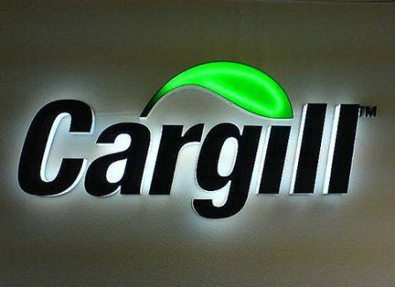
Cargill's event-based social media outreach is built on the belief that the time before an event presents the biggest opportunity for engagement, says Maria Lettman, director of social media at Cargill. Interest peaks in advance of events, so having content ready beforehand is important, she says.
SmartBrief/Marketing 10/5/16
http://www.smartbrief.com/original/2016/10/andy-sernovitz-how-cargill-built-its-global-thought-leadership-position?utm_source=brief

