"Gilmore Girls" Snapchat Push was Slam Dunk for Netflix
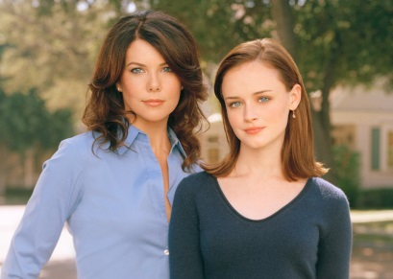
Netflix touted its reboot of "Gilmore Girls" by transforming 200 cafes into Luke's Diner from the show, with coffee cups containing Snapcodes. The one-day event was seen by more than 500,000 people on Snapchat.
Adweek 10/25/16
http://www.adweek.com/news/technology/netflixs-gilmore-girls-pop-coffee-shops-were-massive-hit-snapchat-174248

