GM, Amazon Drive Alexa Engagement With Vehicle Integration
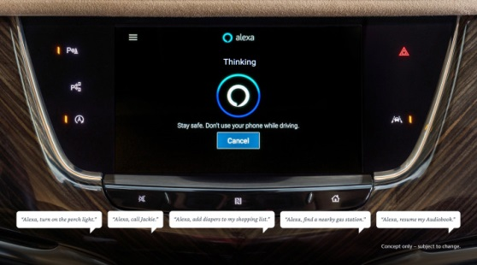
In 2020, GM is integrating the Amazon Alexa app into millions of its 2018 and newer cars, trucks and crossovers for its Cadillac, Buick, GMC and Chevrolet vehicles. Consumers will be able to tap into "tens of thousands" of Alexa skills, including playing podcasts and adding products to their shopping carts, and the two firms will reportedly share data gleaned from the voice commands, according to CNBC.
MediaPost Communications 9/25/19
https://www.mediapost.com/publications/article/341199/general-motors-partners-with-amazon-to-add-in-vehi.html
Image credit:
https://www.rocketnews.com/wp-content/uploads/2019/09/GM_Alexa_Thinking-1.jpg

