Google Joins Dish In Talks To Create 4th Mobile Carrier
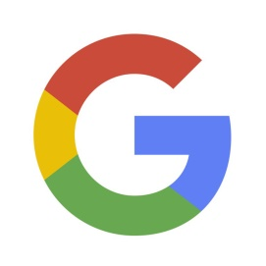
The idea is for Alphabet-owned Google and Dish to launch a new wireless giant with the help of assets acquired from T-Mobile, which is now under pressure from the Department of Justice to aid such a project in order to get clearance for its $26 billion merger with Sprint, according to sources close to the situation.
New York Post 7.7.19
https://nypost.com/2019/07/07/google-joins-dish-network-in-talks-to-create-4th-mobile-carrier/?utm_source=Listrak&utm_medium=Email&utm_term=Google%2c+Dish+In+Talks+To+Form+Mobile+Carrier&utm_campaign=Gray+Is+Poised+For+Election+Ad+Deluge

