Group of Bars, Restaurants Challenges DIRECTV's NFL Sunday Ticket
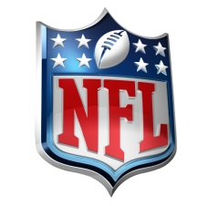
A group of bars and restaurants around the country has filed a class-action antitrust lawsuit against the NFL and DIRECTV's Sunday Ticket, saying that the package's pricing is too high and that the NFL is the only major sport with "an exclusive out-of-market broadcasting arrangement." A bar with 100-patron capacity is charged $2,314 for Sunday Ticket, while establishments such as Las Vegas hotels can pay more than $120,000 a year, the lawsuit states.
Variety 7/14/15
http://variety.com/2015/tv/news/nfl-directv-deal-antitrust-lawsuit-sunday-ticket-1201540051/

