H&M Uses Influencers, Polls to Create Dress Designs
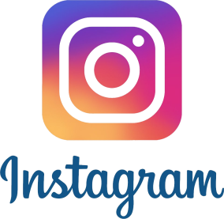
Business Insider reports that H&M tapped nine Instagram influencers to use polls within Stories to ask consumers what they thought about potential clothing designs -- all of which will inform the design of two dresses for the company's new millennial-focused brand, Nyden. The polls attracted over 425,000 views over two weeks and 35,000 votes.
Marketing Dive 7/25/18
https://www.marketingdive.com/news/business-insider-hm-taps-instagram-influencers-user-polling-to-inform-cl/528552/

