Hallmark’s Flip-Flop on Same-Sex Ads Backfires
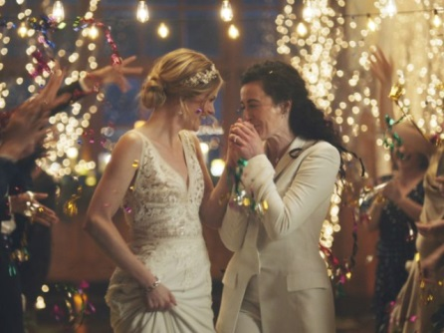
The Hallmark Channel’s decision to pull, then reinstate a commercial that featured a same-sex couple kissing shows how controversy can generate more publicity than simply ignoring it. The company also didn’t help matters by reversing its decision following the backlash.
TVNewsCheck 12.17.19
https://tvnewscheck.com/article/top-news/242364/hallmarks-flip-flop-on-same-sex-ads-backfires/?utm_source=Listrak&utm_medium=Email&utm_term=Hallmark%26%23039%3bs+Flip-Flop+On+Same-Sex+Ads+Backfires&utm_campaign=News+Orgs+Set+Goals+For+Election+Coverage
Image credit:
https://dailytruthreport.com/wp-content/uploads/2019/12/Hallmarkadpull1.jpg

