"Happy Birthday" Copyright Ruled to Be Invalid
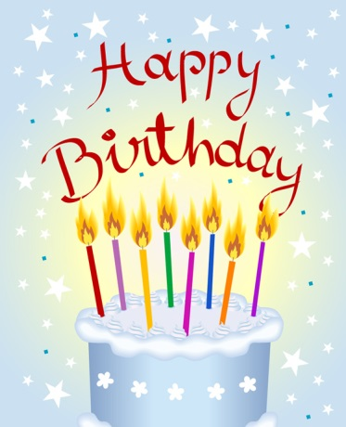
The world's most popular English-language song is potentially free from copyright after a federal judge ruled on Tuesday that filmmakers challenging Warner/Chappell Music's hold on "Happy Birthday to You" should be granted summary judgment.
The Hollywood Reporter 9.22.15
http://www.hollywoodreporter.com/thr-esq/happy-birthday-copyright-ruled-be-826528

