HBO Max Leads In Streaming App Downloads For Mobile
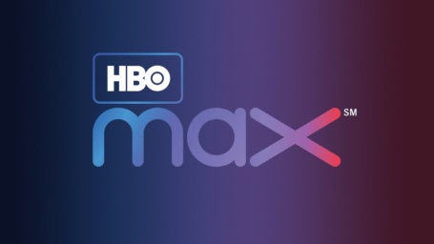
HBO Max has the most US-based downloads of any mobile app for streaming video, followed by Disney+ and Netflix, Apptopia reports. Disney+ takes the lead for US gross income, with HBO Max in second place.
FierceVideo 11/1/21
https://www.fiercevideo.com/video/hbo-max-leads-mobile-streaming-app-downloads-2021

