Heirs of "Andy Griffith" Theme Creators Sue CBS
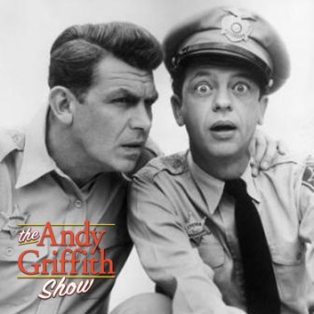
CBS' sale of DVD versions of "The Andy Griffith Show" constitutes exploitation and copyright infringement, as the network doesn't own the rights to the theme song, a lawsuit filed by the original songwriters' heirs says. The suit is seeking damages and an injunction to keep CBS from using the theme.
The Hollywood Reporter 5/24/19
https://www.hollywoodreporter.com/thr-esq/cbs-sued-andy-griffith-show-theme-song-1213484
Image credit:
https://is2-ssl.mzstatic.com/image/thumb/Music6/v4/6b/52/2a/6b522a16-e92b-b798-2836-3bb50fc8470b/source/1200x630bb.jpg

