Hershey Scores Points With In-Game Ads
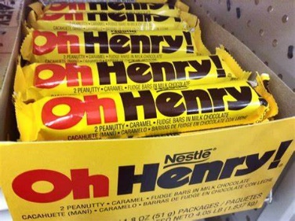
"The Oh Henry! brand tested out intrinsic in-game advertising as the gaming audience is highly relevant to the brand, especially as consumers look to fuel up while they are leveling up in game," writes Oh Henry's Susanne Hartkorn, who notes the effort helped the Hershey brand reach younger consumers.
Marketing Dive 11.15.22
https://www.marketingdive.com/news/Hersheys-gaming-marketing-Gen-Z/636569/
Image credit:
https://squirge.com/wp-content/uploads/2020/10/33685.png

