High School Sports a Mainstay on Radio as Tech Evolves
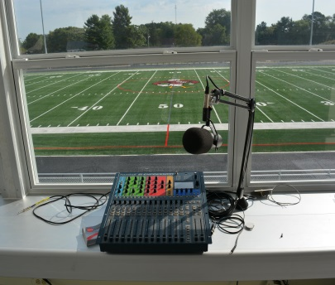
The development of new audio technology has changed many things about radio, but high school sports broadcasts are as much of a fixture on local radio stations as they were in days gone by. Many sportscasters say it's an honor to call high school games, encouraging positive activities among youth while watching a sport they enjoy.
Evansville Courier & Press (Ind.)10/4/19
https://www.courierpress.com/story/sports/high-school/2019/10/04/tech-changes-high-school-sports-radio-broadcasts-remain-tradition/2154043001/
Image credit:
http://www.gannett-cdn.com/-mm-/4089133338ed420934e4295ae13c7632e2a0c3bf/c=334-0-5667-4000/local/-/media/2015/08/27/Salisbury/B9318613283Z.1_20150827174957_000_GC8BOCTAI.1-0.jpg

