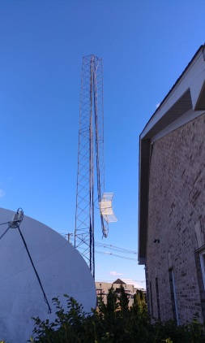
High Winds Destroy Ky. Radio Station Tower
Strong winds on Nov. 27 have left Elizabethtown, Ky., radio station WAKY-FM confined to online streaming after its tower snapped in half. Repairs to allow the station to resume normal broadcasting could take a few weeks, says Rene Bell, the managing partner at station owner W&B Broadcasting.
Radio Ink 12/2/19
https://radioink.com/2019/12/02/heavy-winds-snap-radio-tower-in-half/
Image credit:
https://www.radioworld.com/wp-content/uploads/2019/12/WAKY_tower.jpg

